**Software Requirement Specification (SRS)**

**for**

**BuyUsedBooks Application**

**Introduction:**

An online BuyUsedBooks software Application projects that acts as a central database containing various second hand books in stock along with their title, author and cost. This project is a website that acts as a central bookstore. This web project is developed using Angular as the front end and MS.NET, MYSQL as a back-end. The MYSQL database stores various book related details. A user visiting the website can see a wide range of books arranged in respective categories. The user may select the desired book and view its price. The user may even search for specific books on the website. Once the user selects a book , he then has to fill in a form and the book is booked for the user.

The software has the following three main components:-

1. Implement new users to register and login.

2. Implement the user to choose any book.

3. Implement the user to buy books.

The website will be implemented using MS.NET as the programming language.MYSQL database will be used to link databases.

**Purpose:**

This document is meant to delineate the features of BuyUsedBooks, so as to serve as a guide to the developers on one hand and a software validation document for the prospective client on the other.

The Online BuyUsedBooks web application is used to provide complete solutions for customers through single get way using the internet.The online bookshop will contain stories, study material, any courses books like Engineeringfield and some other courses, and be available to everyone. Many students find textbooks too expensive to buy at school bookstores and many courses only use the required textbooks a few days in a semester. This becomes very wasteful and frustrating for students & other people. This online BuyUsedBooks application provides a solution to this. It will provide a service in which students can buy books online without any treble. There will be free shipping. They do need to register with the site in order to book. Payment information will be requested after adding any numbers of books in the cart.

**Scope:**

This system allows bookshops and customer's to maintain their cart for adding or removing the book over the internet.

**Overview:**

This System provides an easy solution to customer's to buy the product without going to the shop and also sell their products online.

**Additional Information:**

The system works on an internet server, so it will be operated by any end user for the buying purpose with a secure platform. This system protects the integrity of the sellers and buyers, provides easy returns, buying policies and offers.

**General Description:**

The Online BuyUsedBooks application helps to manage the items in the shoppers' carts and also helps customers to purchase.The online shopping system will use the internet as the sole method for selling goods to its consumers.

**Advantages:**

∙Customers can get their book delivered instead of actually going and buying the book. They can make payment online itself.

∙Customers can save their money to buy Used books instead of buying new books.

∙ This system saves both time and travelling cost of customers.

∙ Users can get to know different kinds of books that they were unaware of by just searching in the system using keywords.

**Applications:**

The system can be very well used by the book shopkeepers to expand their customers.

**Functional Requirement:**

This section provides a requirement overview of the system. Various functional modules that can be implemented by the system will be-

**Description:**

Registration if customer wants to buy the product then he/she must be registered, Unregistered user can not get to shopping cart.Login Customer logins to the system by entering valid user id and password for shopping.End User can Browse Products , their categories as well, he/ she can add products to her/his wishlist.Payment for customer; there are many of secure billing will be prepaid as debit or credit cart,postpaid as after shipping ,check or bank draft.Logout after the payment of the product the customer will logged out.Report Generation after all transaction the system can generate the portable file (.pdf)then sent one copy to customer's Email- address and another one for the system database to calculate the monthly transaction. The term client/server refers primarily to an architecture or logical division of responsibilities, the client is the application (also known as the front-end), and the server is the RDBMS (also known as the back-end). A client/server system is a distributed system in which,Some sites are client sites and others are server sites. All the data resides at the server sites.All applications execute at the client sites

**Technical Issues:**

This system will work on client-Server architecture. It will require an internet server.The system should support some commonly used browser such as Chrome etc.Interface Requirement Various interfaces for the product could be

1.Login Page

2.Registration Form

3.Product Page

4.Shopping Cart

5.Shipping Details

6.Purchase history

7.Account Settings

8.Payment Gateways

**Hardware Interface:**

The System must run over the internet, All the hardware shall require a connection to the internet will be hardware interface for the system.

e.g. modem, WAN, LAN

Specialized Server Infrastructure Hardware

The system should use distributed servers i.e cloud for managing large amounts of data so as to make it appear as a single unit for end-users. The system should have proper clusters for backup.

**Software Interface:**

The system is on the server so it requires a scripting language like JSP. The system should be able to exchange data using XML, JASON or any advanced technology. The system requires DataBase also for the store any transaction of the system like MySql or oracle, or SQL server etc. System also requires DNS (Domain Name space) for the naming on the internet.

http://www.amazon.in

At the end-user needs a web browser to interact with the system.

**Performance Requirement:**

There is no performance requirement in this system, because the server request and response to client is totally based on internet connection of end user.

**Design Constraints:**

This system should be developed using the Standard Web Page Development Tool , which conforms to GUI standards such as HTML, XML, JSON,etc.

The system should support various RDBMS and Cloud Technologies.

**UML Diagram:**

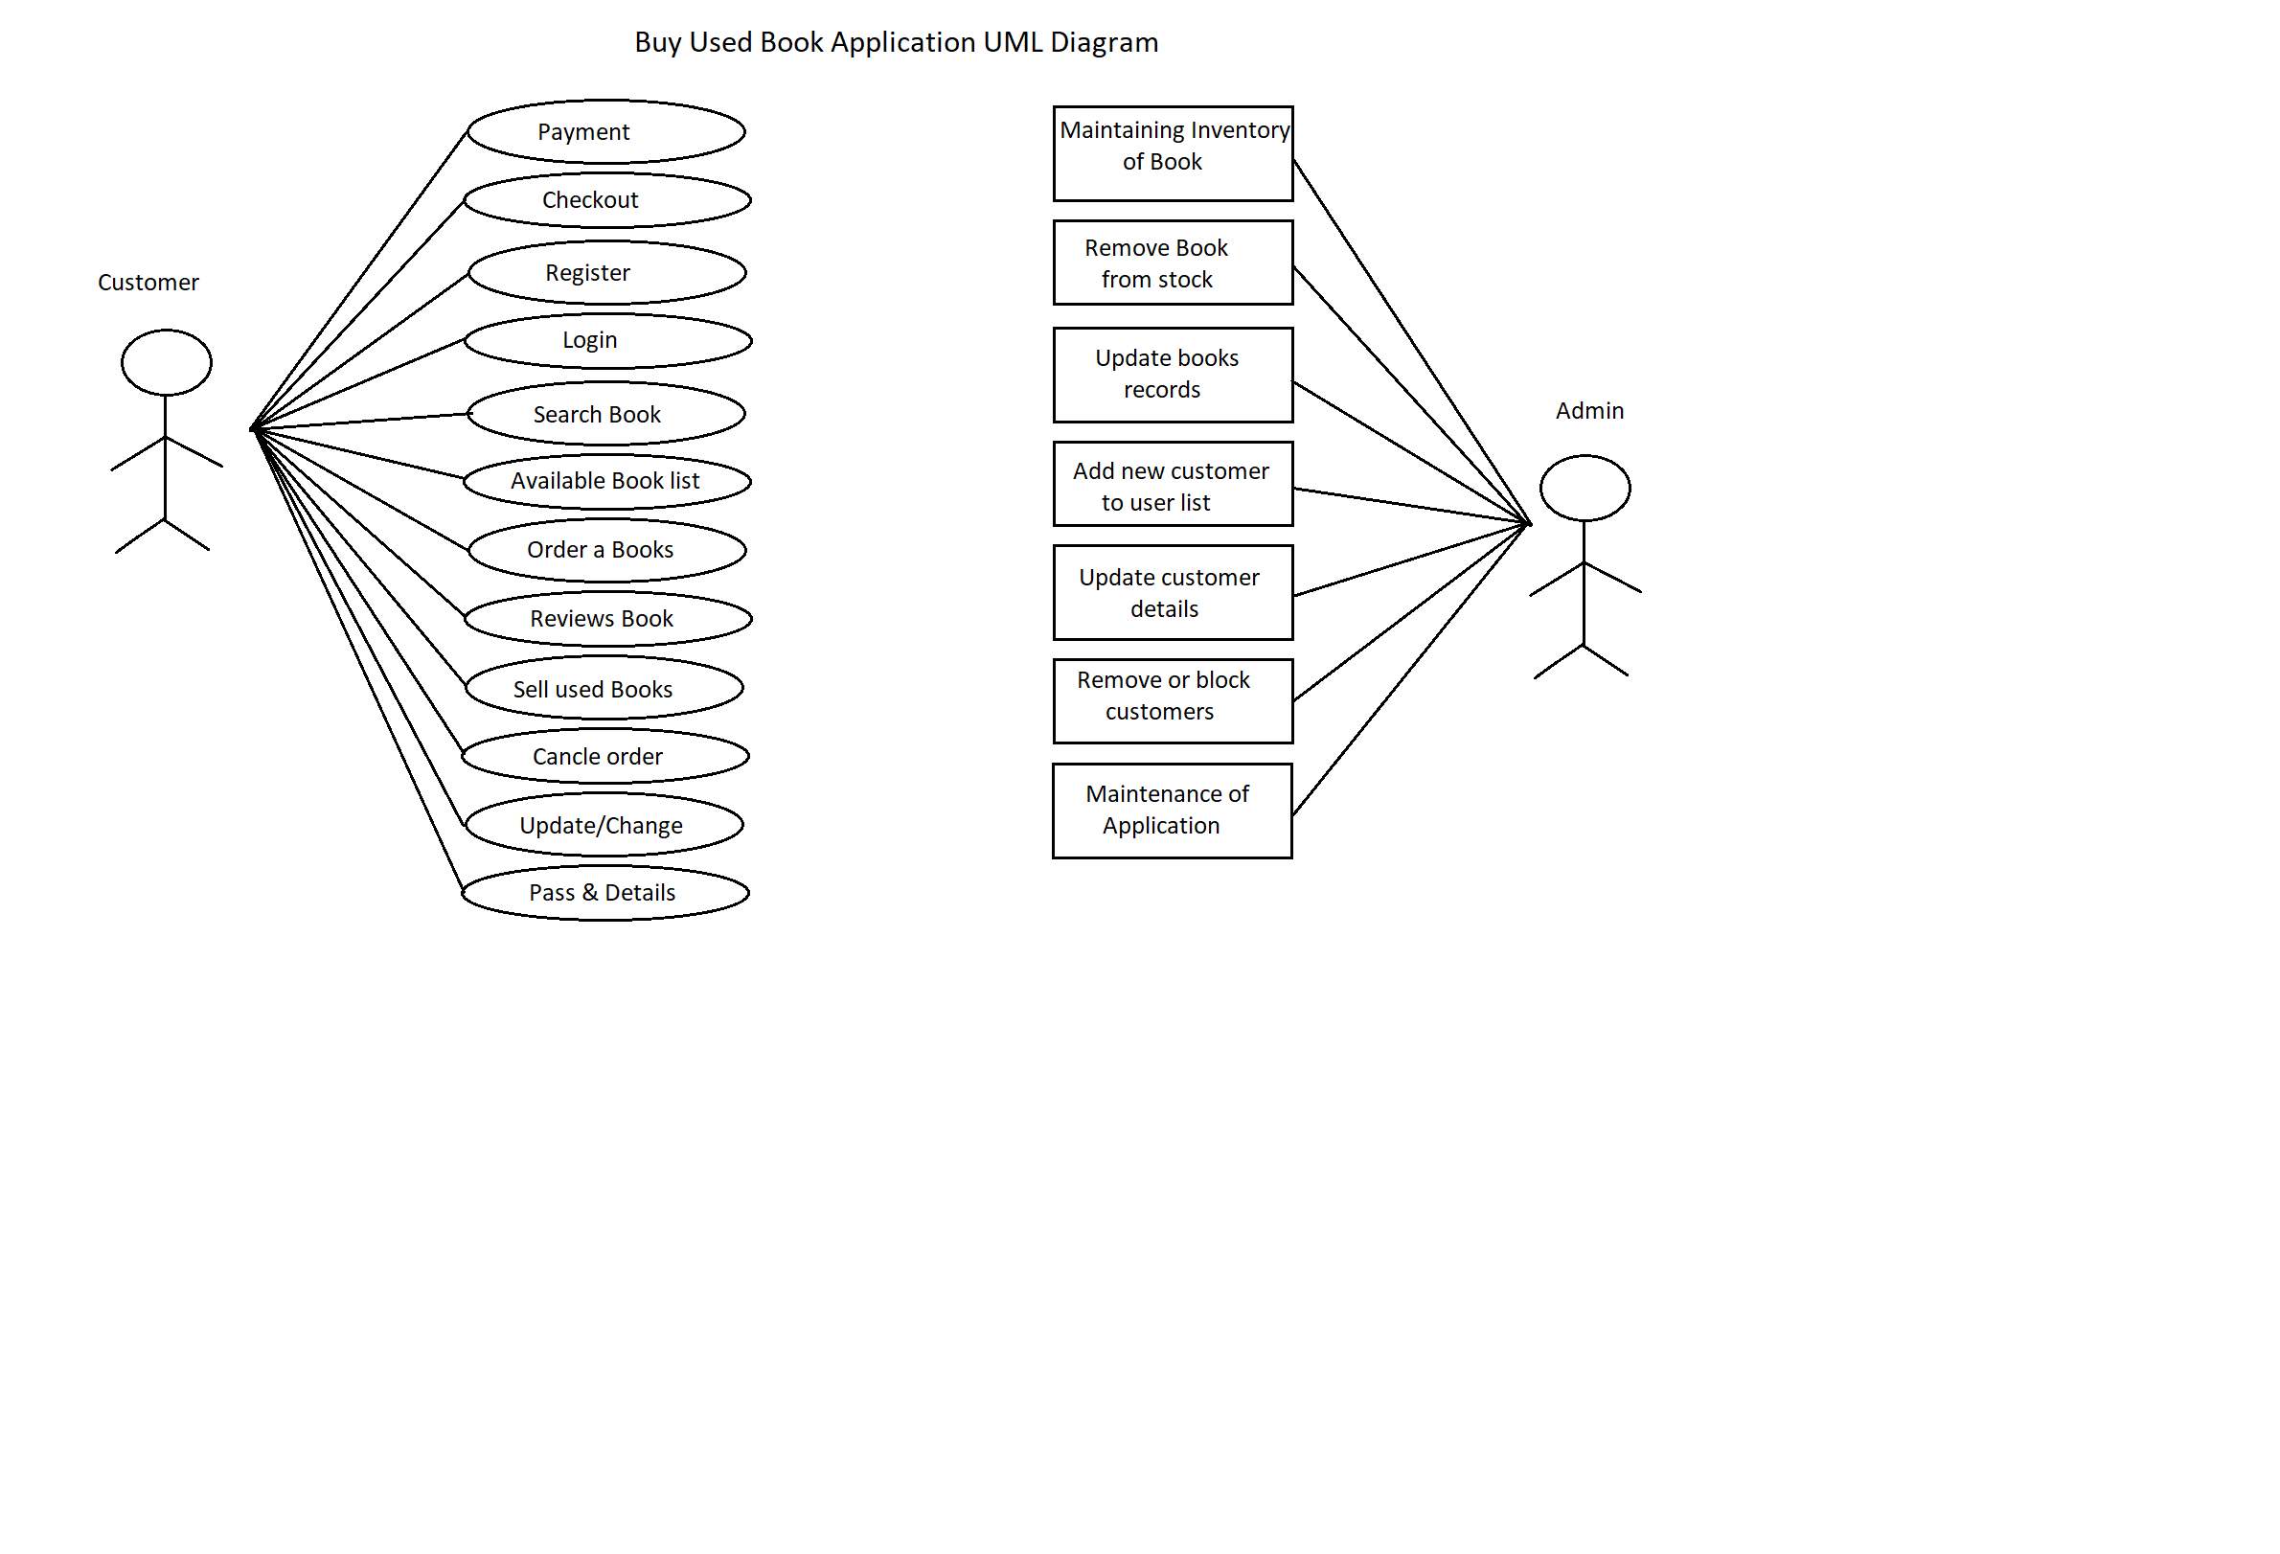

**ER Diagram:**

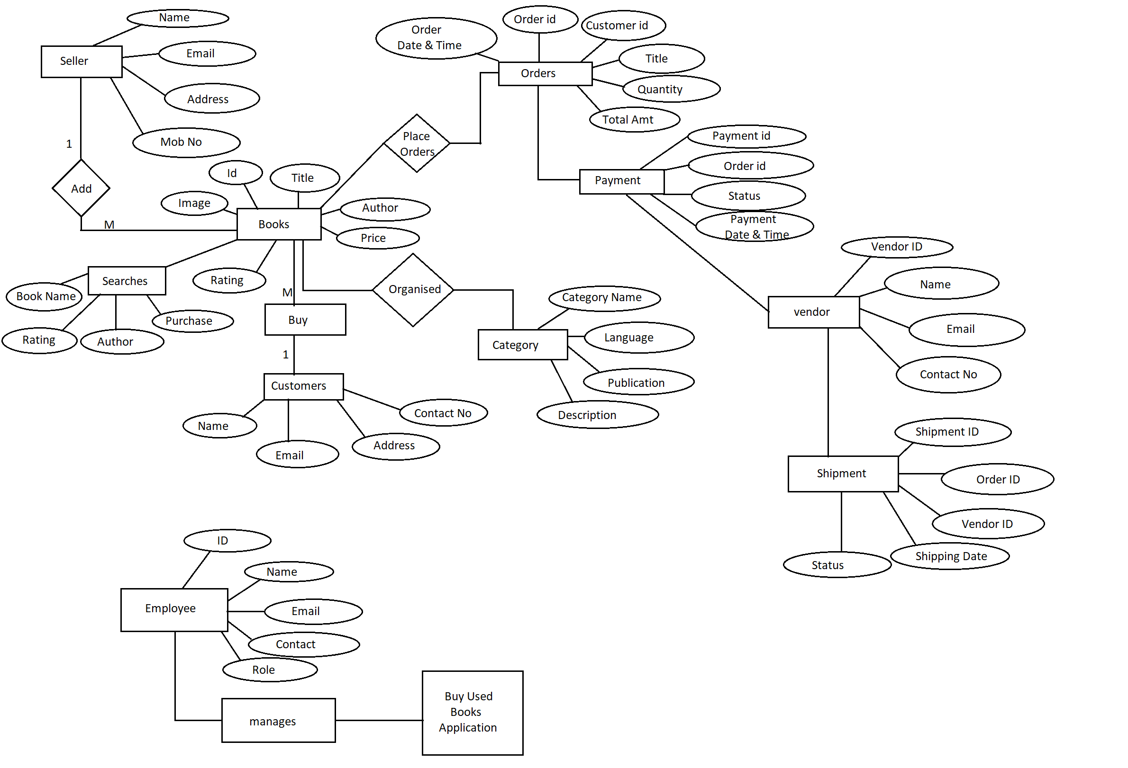

**Non-Functional Requirements**

**1.Security:**

SSL

The System use SSL (Secure Socket Layer) in all transactions that include any confidential customer information.The system must automatically log out all customers after a period of inactivity.he system should not leave any cookies on the customer's computer containing user's password.The system's back-end servers shall only be accessible to authenticated administrators.Sensitive data will be encrypted before being sent over insecure connections like internet. The proper firewalls should be developed to avoid intrusions from the internal or external sources.

**2.Reliability:**

The system provides storage of all databases on redundant computers with automatic switchover. The main pillar of reliability of the system is the backup of the database which is continuously maintained and updated to reflect the most recent changes.

**3: Availability:**

The system should be available at all times.meaning the user can access it using a web browser, only restricted by the down time of the server on which the system runs. In case of a hardware failure or database corruption, a replacement page will be shown. uptime : It mean 24 * 7 availability

**4: Maintainability:**

A commercial database is used for maintaining the database and application server takes care of the site. The maintainability can be done efficiently.

**5.Portability:**

The application is HTML and scripting language based (Javascript). So the end user part is fully portable and any system using any web browser should be able to use the features of the system,including any hardware platform that is available or will be available in the future.

An end-user uses this system on an OS;either it is Windows or Linux.

The System shall run on PC, Laptops and PDA.etc.

The technology should be transferable to different environments easily.

**6.Accessibility:**

Only registered users should be allowed to process the orders after authentications.

Only GUI access of the system should be permitted to end users.

**7.Policies:**

The system should adhere to all the legal formalities of the particular countries. The system should maintain security related to sensitive data.

**8.Efficiency:**

The system should provide good throughput and response to multiple users without burdening the system by using an appropriate number of servers.

**9.Safety:**

Software should not harm the ethical and environmental conditions of the end users machine.

**10.Modulariy:**

The system should have a user -friendly interface.

It should be easily updated,modified and reused.

**Operational Scenario:**

Customer Interaction

The Customer wants to buy an item. The system shows all product categories to customers. If a customer selects an item then those items are listed in the shopping cart for buying. The payment will be made with credit card or debit card. If a customer wants to cancel the order before shopping then he or she can cancel it. Customers can see the buying report on account details. Customers will receive an email about purchase done.

**Shopper Interaction:**

Staff Interaction:

BOD (Board Of Directors)

**Preliminary Schedule: :**

1.Login

2.Manage customer database Browse category

3.add or remove item from cart

4. Manage customer database

5.update item category

6.approve/reject shop creation

7.shipping order

8.Logout

9.Give feedback

10.payment

11.ByCreditCart By Debit Card By online banking

12.Visit Site

13.Create new account

14.View account details

15.Cancel order before shipping

16.Registration

17.Order tracking

18.Return Policies

19.Customer Support